**Introducing**

Discovery Solutions

**Featuring Pre-packaged, Industry Specific Use Cases**

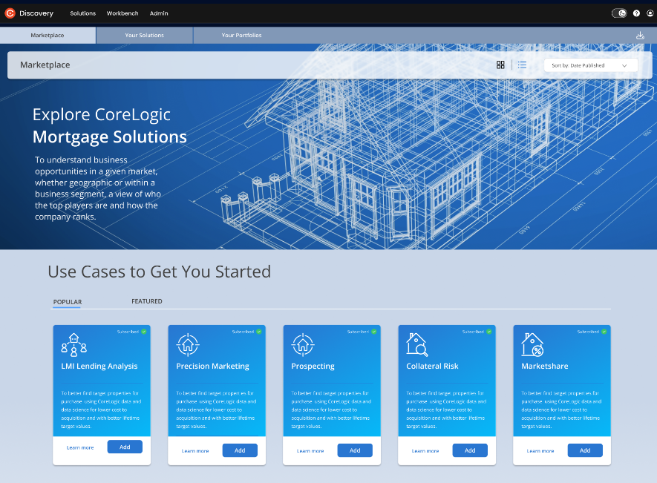**For Data-driven Decision Making**

Discovery Solutions is the next horizon of the Discovery Platform, incorporating advanced analytics, deep industry expertise, and customizable tools to help you optimize your portfolio. Featuring an easy-to-use dashboard, our out-of-the-box Use Cases serve the Financial Services industry, including Real Estate, Mortgage, Banks, Insurance, Capital Markets, Investors, and Government Agencies.

**Discovery Solutions provides:**

* A comprehensive platform
* Easy access to industry-specific data, analytics, and insights
* Customizable pre-packaged Use Cases
* Collaboration with data experts
* Insights to help you understand and grow your business

**Key Features:**

* **CLIP® Enablement:** Easily access thisIndustry-leading geospatial property identifier directly in your environment, without moving your data. By using CLIP, we can quickly analyze and improve the accuracy of your portfolio, giving you confidence in your analytic understanding.
* **Visualizations:** User-friendly maps, dashboards, and configurable visualizations make data accessible to various users within a company, including those in business, marketing, and other non-tech roles.
* **Integration:** Seamlessly export insights to your Cloud Instance or CRM, or download visualizations to a presentation deck or report, ensuring smooth interoperability with existing systems.
* **Industry Specific Use Cases:** Tailored, pre-packaged solutions and insights for specific industries, address the unique challenges and needs of financial services, public sector, retail, and utilities, making it easier for organizations to extract value from the data.

**Explore the first set of Use Cases for the Mortgage Industry:**

**Lost Leads**

****The Lost Leads Use Case is a powerful tool that helps mortgage companies pinpoint their competitors and discover why they're losing leads. By providing insights into lead quality, lender choices, and the reasons behind those choices, Lost Leads analysis enables mortgage businesses to strengthen their processes and revise their customer engagement strategies for better performance.

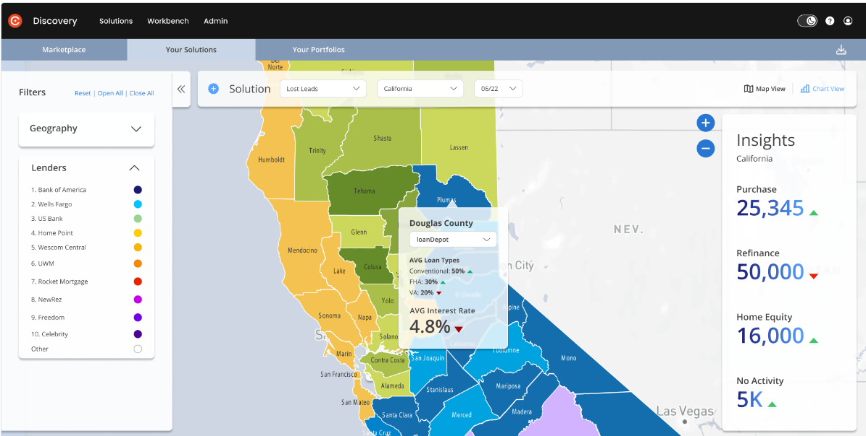

**LMI Lending**

****LMI Lending provides valuable insights into lending activities within low and moderate-income areas, enabling financial institutions to meet CRA and fair lending initiatives while complying with federal regulations and ESG guidelines.

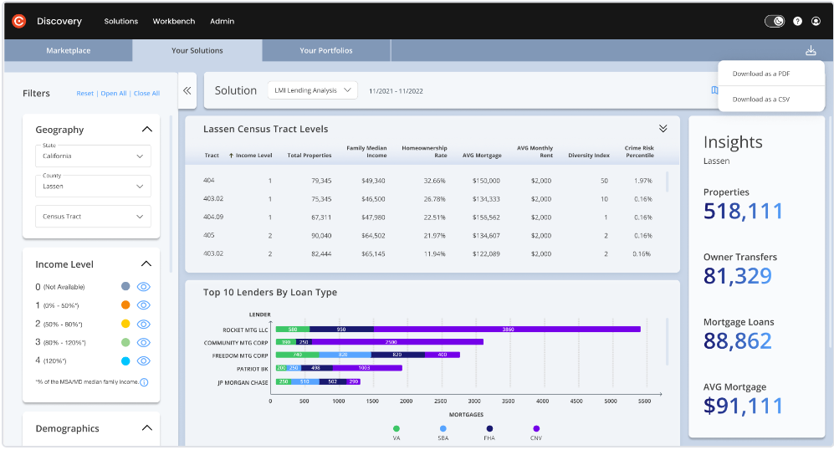

**Market Share**

****With the Market Share Use Case you can gain a comprehensive understanding of your organization's market share and potential growth opportunities within the mortgage industry. This solution provides insights that allow you to validate your marketing strategy, identify underserved gaps, and better understand your competition, to make informed decisions and optimize business performance.

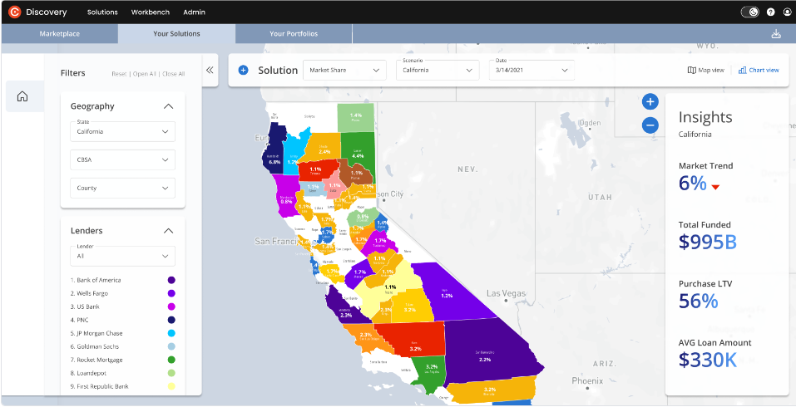

**Payoff**

Payoff helps servicers identify loans in their portfolio that have been paid off due to home sales, payoffs, or refinancing. By providing insights on which lender captured those loans, servicers can better understand their capture rate and take action to strengthen their processes and revise their engagement strategies.

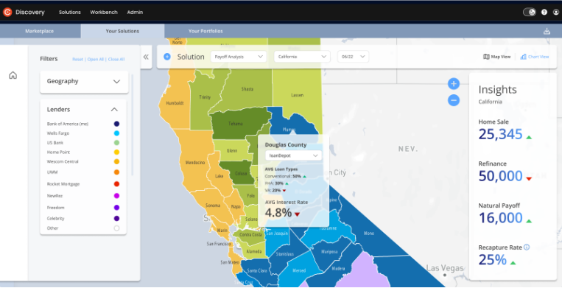

**Precision Marketing**

With Precision Marketing - Home Shopping Application you can know when your customers are searching for a new home. Using geolocative and mobility data, you can understand when and where your customers are shopping. Your customer portfolio will be enriched with property analytic models to reveal customer insights and provide your sales teams with high quality leads on customers that are in market now.

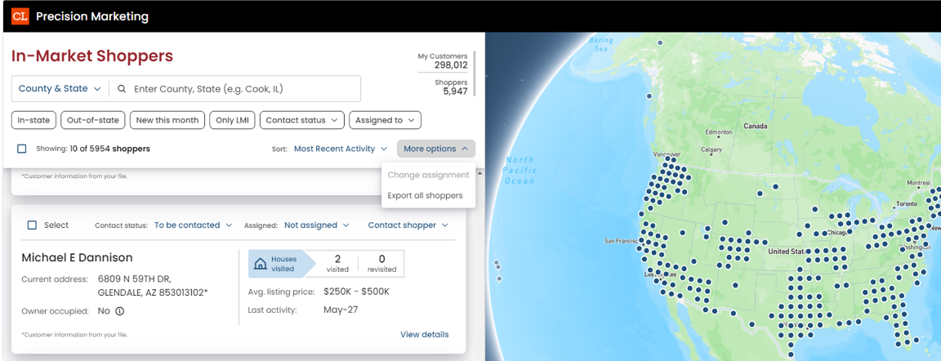

For further information regarding Discovery Solutions and the Use Cases click [here.](https://documentation.discovery.corelogic.com/ddp/discovery-solutions-platform)

For further questions, please contact [customersupport@discoveryplatform.atlassian.net](mailto:customersupport@discoveryplatform.atlassian.net)

© 2023 CoreLogic, Inc. All rights reserved.

CORELOGIC and the CoreLogic logo are trademarks of CoreLogic, Inc. and/or its subsidiaries. All other trademarks are the property of their respective holders.